# MESH COMPUTER GRAPHICS

# PROJECT

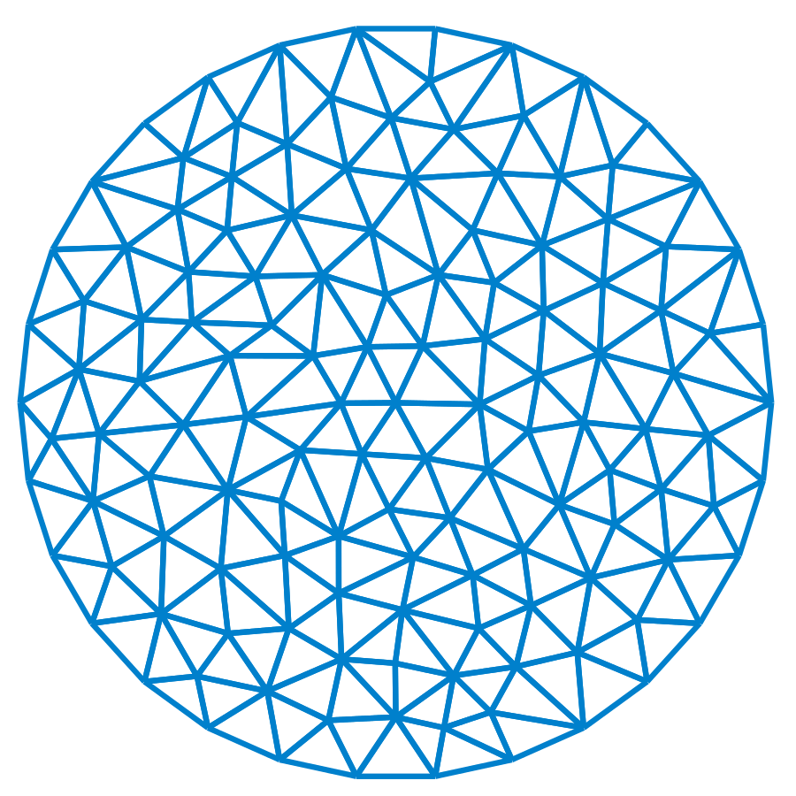

Project submitted by :

**Imed Jaberi**

**&**

**Yassine Omrani**



MEMORY BLOCKS GAME

Our game is made entirely using openGL library and c/c++ with glut (OpenGL Utility Toolkit) .... It’s a memory blocks game which means shortly the player needs to remember the objects position so that he clicks on the similar blocks .... when all the blocks disappear the player wins ... we implemented a menu system and a help menu so the player can use them intuitively.

The player can navigate using the arrows and the return key ( enter ) to confirm your selection ... and we implemented a scoring system and if he completed he can easily replay the game by pressing `R`.